**RATES OF CHEMICAL REACTIONS**

Some chemical reactions occur almost instantaneously. Others such as weathering of rocks are slow. Intermediate reactions take place at rates which easily be measured.

E.g. Decomposition of hydrogen peroxide

H2O2 (l) catalyst 🡪 O2 (g) +H2O (l)

2H2O2 (l) catalyst 🡪 O2 (g) +2H2O (l)

**Acid-Metal Reactions**

Ca (s) +2HCl (aq) 🡪 CaCl2 (aq) + H2 (g)

During a chemical reaction, the concentration of reactants decrease by the concentration of products increased, that is, reactants are continuously converted to products. The rate of a chemical reaction is given by

Rate of reaction = change in concentration of reactants/time taken for change

Or

Rate of Reaction= change in concentration of products/time taken for change

The following factors are dependent on the following changes that is reactions can be measured using these changes

1. Pressure(gaseous reactants)
2. Change in volume
3. pH(potential hydrogen)
4. Intensity of color

**Conditions required for chemical reactions to take place**

1. Reactant molecules collide

Old bonds may break and new bonds may form during collision.

HCl (aq) + NaOH (aq) 🡪 NaCl (aq) + H20 (l)

Bonds broken: H+, Cl-, Na+, OH-

1. Reactant molecules must collide in correct orientation(position)

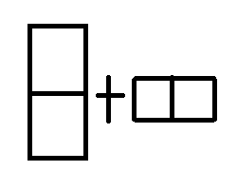

No reaction (incorrect orientation)

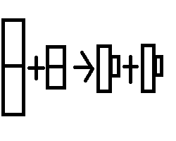

Reaction (correct orientation)

1. Reactant molecules must have energy greater than activation energy. Activation energy is the minimal energy required to break the bonds in reactant molecules and become sufficiently activated for products to be formed.

**Questions**

Balance the following equations

1. Mg (s) + O2 (g) 🡪 MgO (s)

______________________________________________________________________________________________

1. Al (s) + N2 (g) 🡪 AlN (g)

______________________________________________________________________________________________

1. NaOH (aq) +H3PO4 (aq) 🡪 Na3PO4 (aq) + H2O (l)

______________________________________________________________________________________________

1. CH3CH2OH (l) + O2 (g) 🡪 CO2 (g) + H20 (l)

______________________________________________________________________________________________

**Factors which affect the rates of chemical reaction**

1. Concentration
2. Temperature
3. Particle size/surface area
4. Catalysts
5. Pressure (for gaseous systems)
6. Light (for some reactions)

**Concentration**

An increase in concentration means there are more reactant molecules in a given volume. This may lead to more frequent collisions and to a faster reaction rate.

**Temperature**

Particles move faster when the temperature is raised and this means that: particles collide more frequently and the collisions are more energetic. As a result, more particles have energy greater than activation energy. As a result, the reaction rate is faster.

**Particle Size/Surface Area**

Chemical reactions involving solids are increased by increasing the surface area of the solid (subdivisions). In such reactions occur between moving molecules and the solid reactants. The smaller the particles of the solid are, the greater surface are for collisions and greater the reaction rate.

**Catalysts**

A catalyst is a substance or chemical that speeds up a chemical reaction but is not used up itself. The rates of many reactions can be changed by the addition of small amounts of catalysts.

Catalysts lower the activation energy thus, ensuring that many more collisions are successful. Catalysts provide a different and easier way for the reactants to form products.

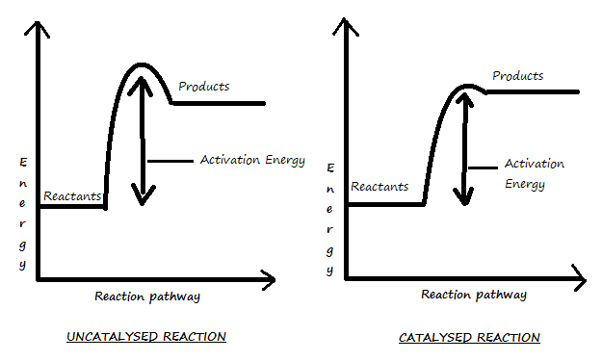

**Light**

Light does not affect the rate of the majority of chemical reactions. Those which are affected are among the most important of reactions.

E.g. Photosynthesis

Reactions which are accelerated by light are known as photo-chemical reactions.

**Pressure**

When pressure is applied to a gaseous reactant, the reactant molecules are brought closer, and more collision takes place, thus, the rate of the reaction is increased.

E.g. The production of ammonia requires pressure in order to bring nitrogen and hydrogen closer together.

**SAMPLE**

Concentration

The following graph shows the reaction of 5cm lengths of magnesium ribbon with three different concentrations of hydrochloric acid at 270C.

Variables

Fixed variables - Magnesium, Temperature

Manipulated variable (independent variable) - Concentration

Dependent variable (responding variable) - Time taken for reaction to complete

